Custom Paintings that I have done in the past:
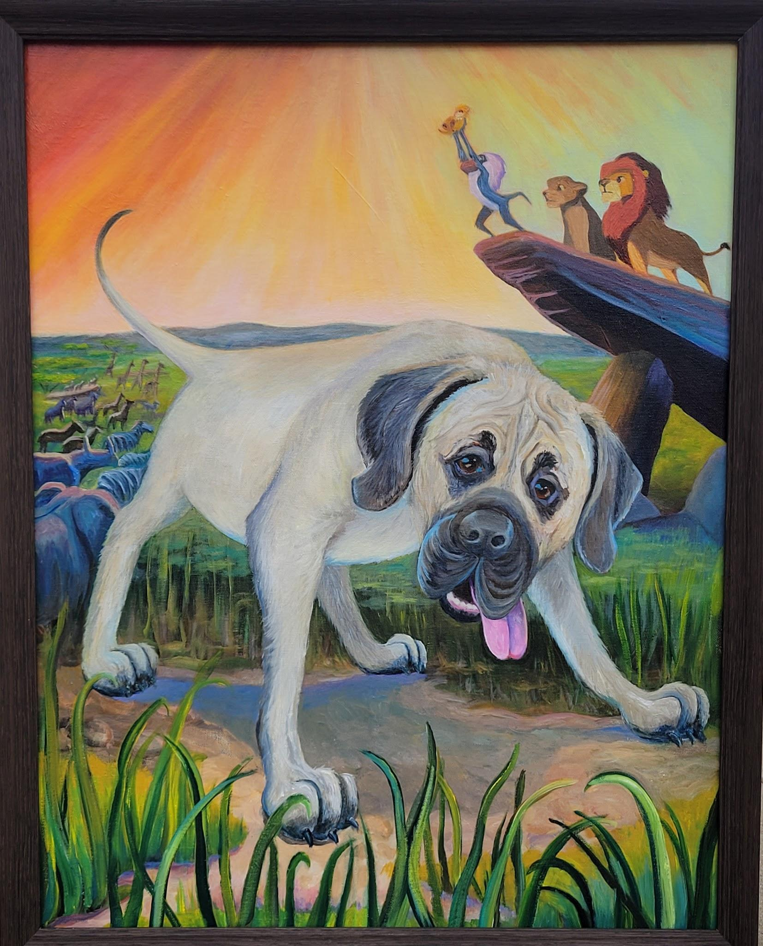
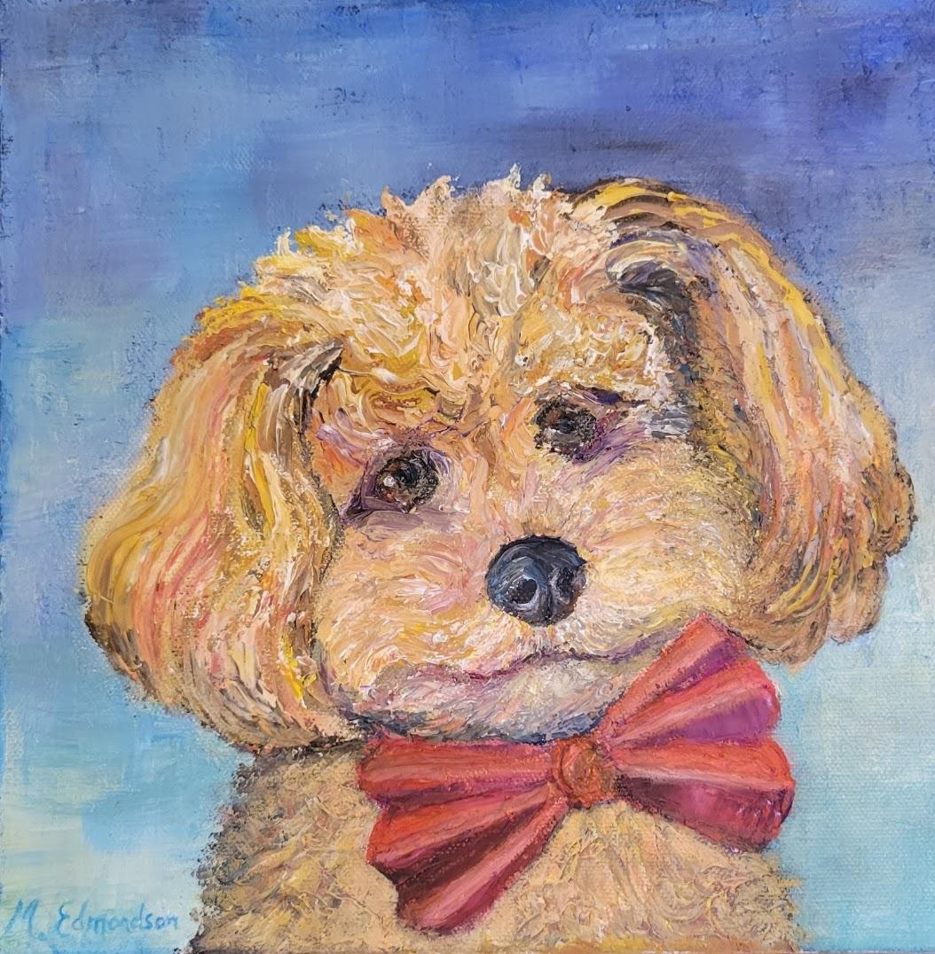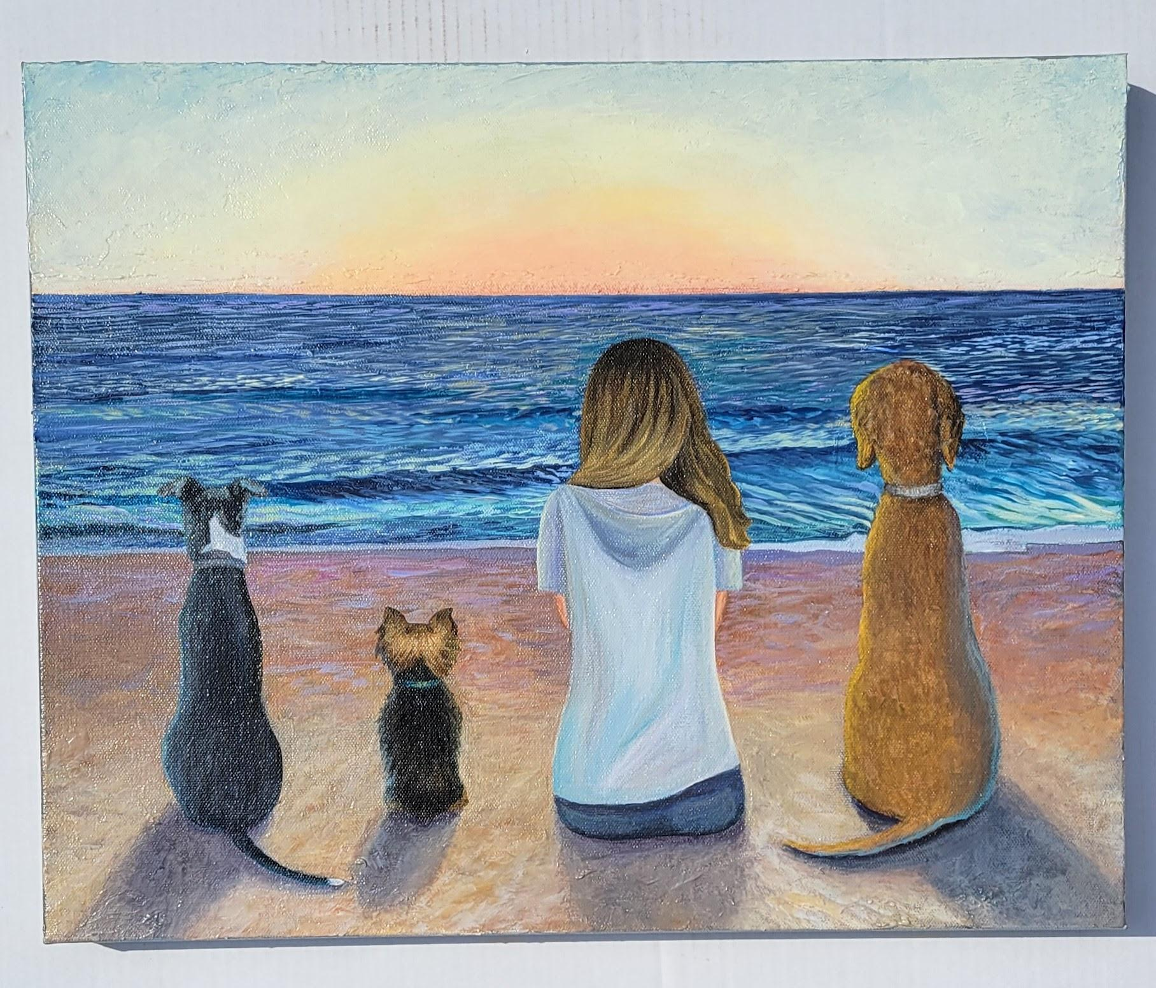
I probably should not post this one as the person who requested it from showed me a print out of a website she tried to plug her dogs into, but the website would not adjust for the scale of one of her dogs so she requested this with her dogs. It is very similar to the website though so probably a copyright problem.

Commissions info:

Pet portraits:
-Provide reference photos, concepts, and descriptions with any inspiration and requests.
-If local and possible I would like to meet your pet and take some additional photos.
-you can choose your media from acrylic on canvas, watercolor and water gouache on paper, pastel or charcoal on paper, or mixed media.
-The complexity of pet portraits is more time consuming because a true likeness is desired. How many pets are in one piece and the scene behind the pet may also increase the length of time to complete the painting. So probably a minimum of $250? and that is for an smaller size. As the size and complexity of the piece increase, so will the price. If larger the price will increase (not sure that we want to say any of this?)
-Place to upload photos, contract (letter of agreement) ?, set up a time to discuss by phone?,
-Timeline average 2-8 weeks to have the commission completed?
-50% deposit to start work after conversation and agreement contract and images received. Once the piece is nearly finished I will review with you the completed piece. If any minor modifications need to be done at this time I will do them. After final approval, I will invoice the remainder of the fee plus sales tax (if you reside in Texas). In the unlikely event that you refuse the work, I will retain the initial deposit but will not charge the final 50%, and I will retain the artwork.
-Framing offered at an additional cost or you may frame independently.

Custom House Portraits:
-Prices depend on the complexity of the house, landscaping visibility, and size of finished piece. Minimum $150- max $500?
-Matting and framing is an option and will be offered at an optional additional cost.
- Photos need to be provided if not a local residence that I can get to?
-maybe a “upload photos here” option? And a contact tab and a payment tab?
-watercolor, water gouache on paper is preferred and suggested but other options such as drawings may be an option.
-Timeline: While I will try to be as timely as possible, the timeline of completed work depends on first come first served basis of my current work schedule. Possible turn around time could be 2 weeks to 8 weeks? (This is really rough, just thoughts) Maybe should just say timeline will be discussed with project specifications ?
- Example of my house painting that I did. I need to have the name and address blurred if you can do that or edit it out please.
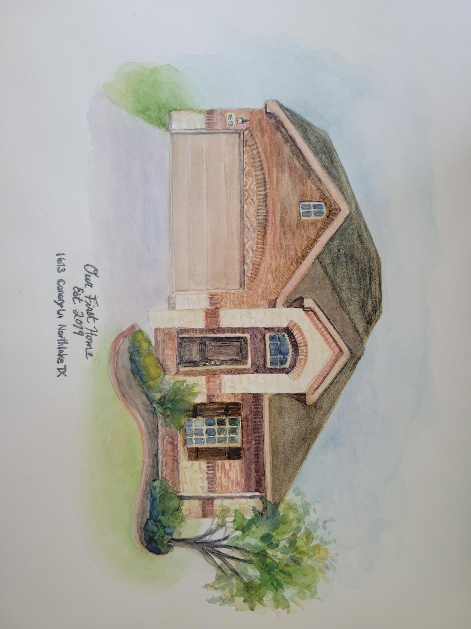
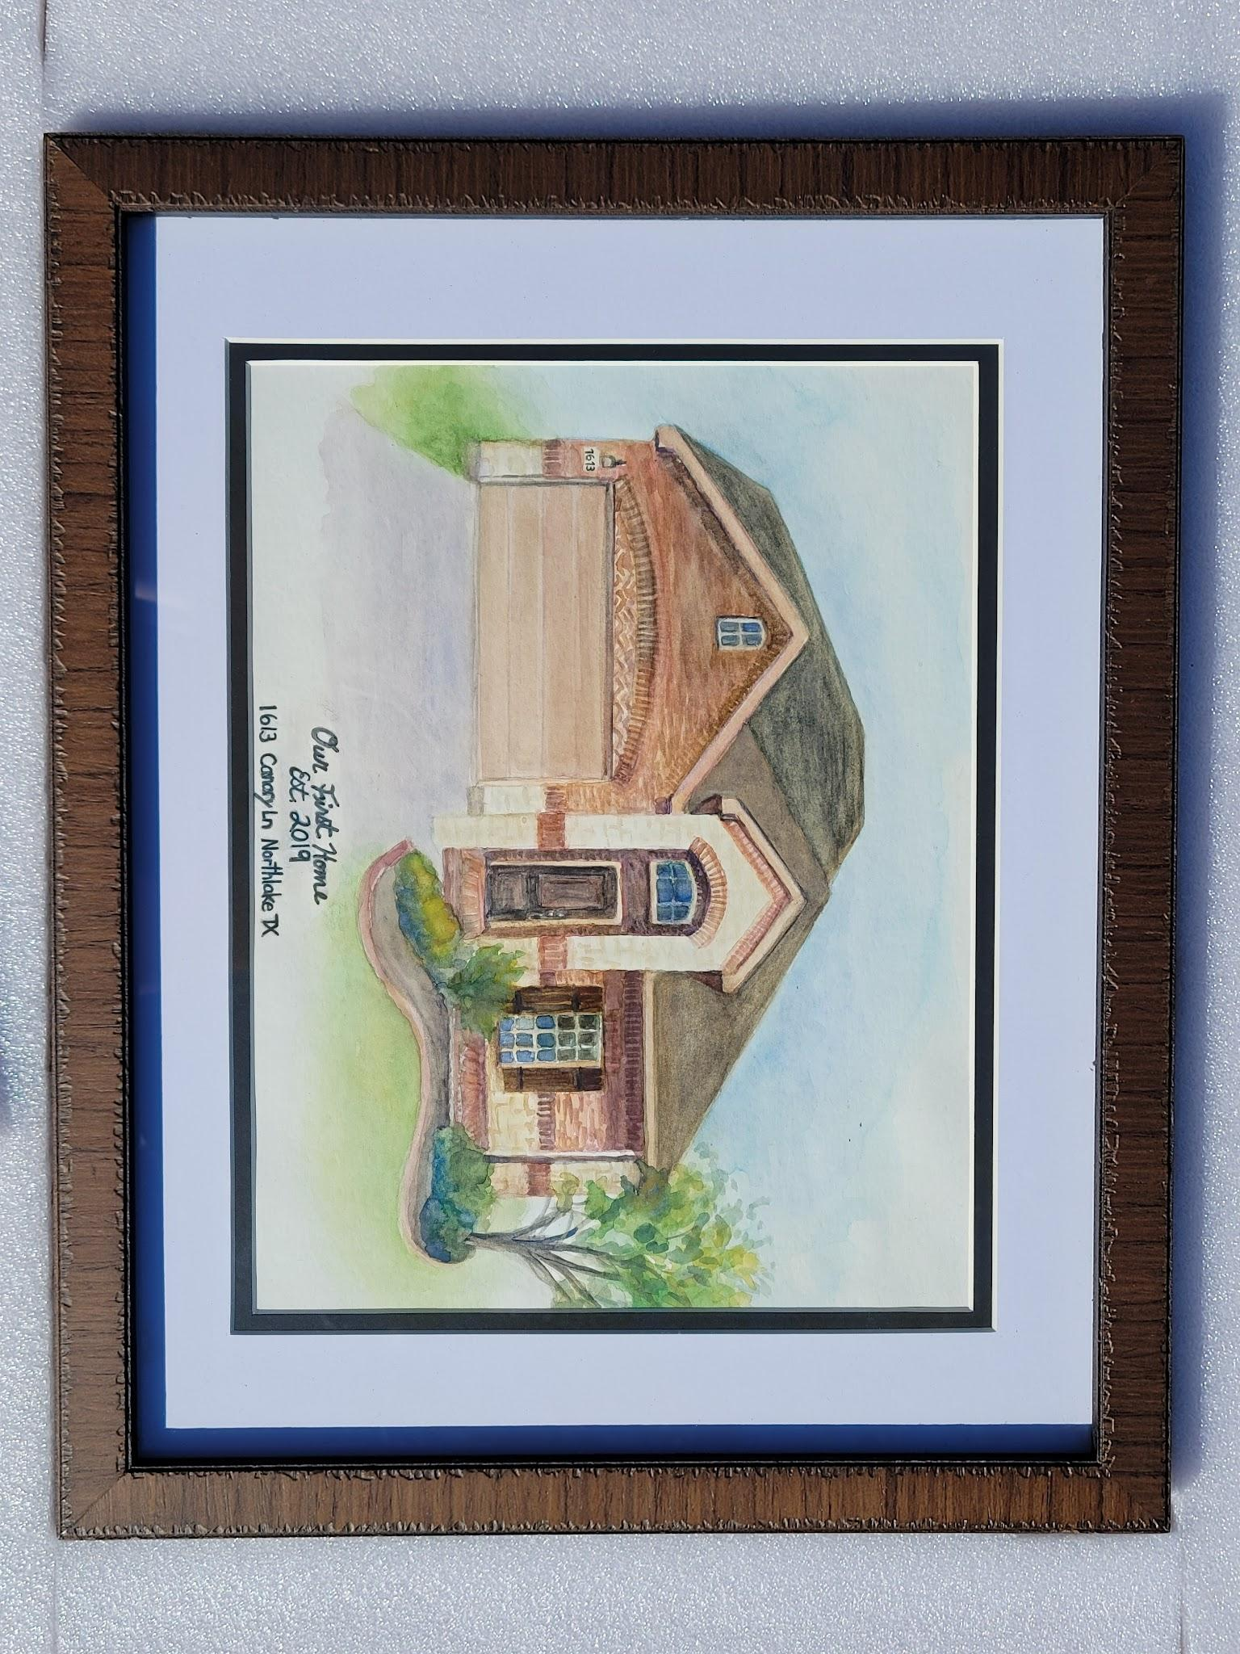
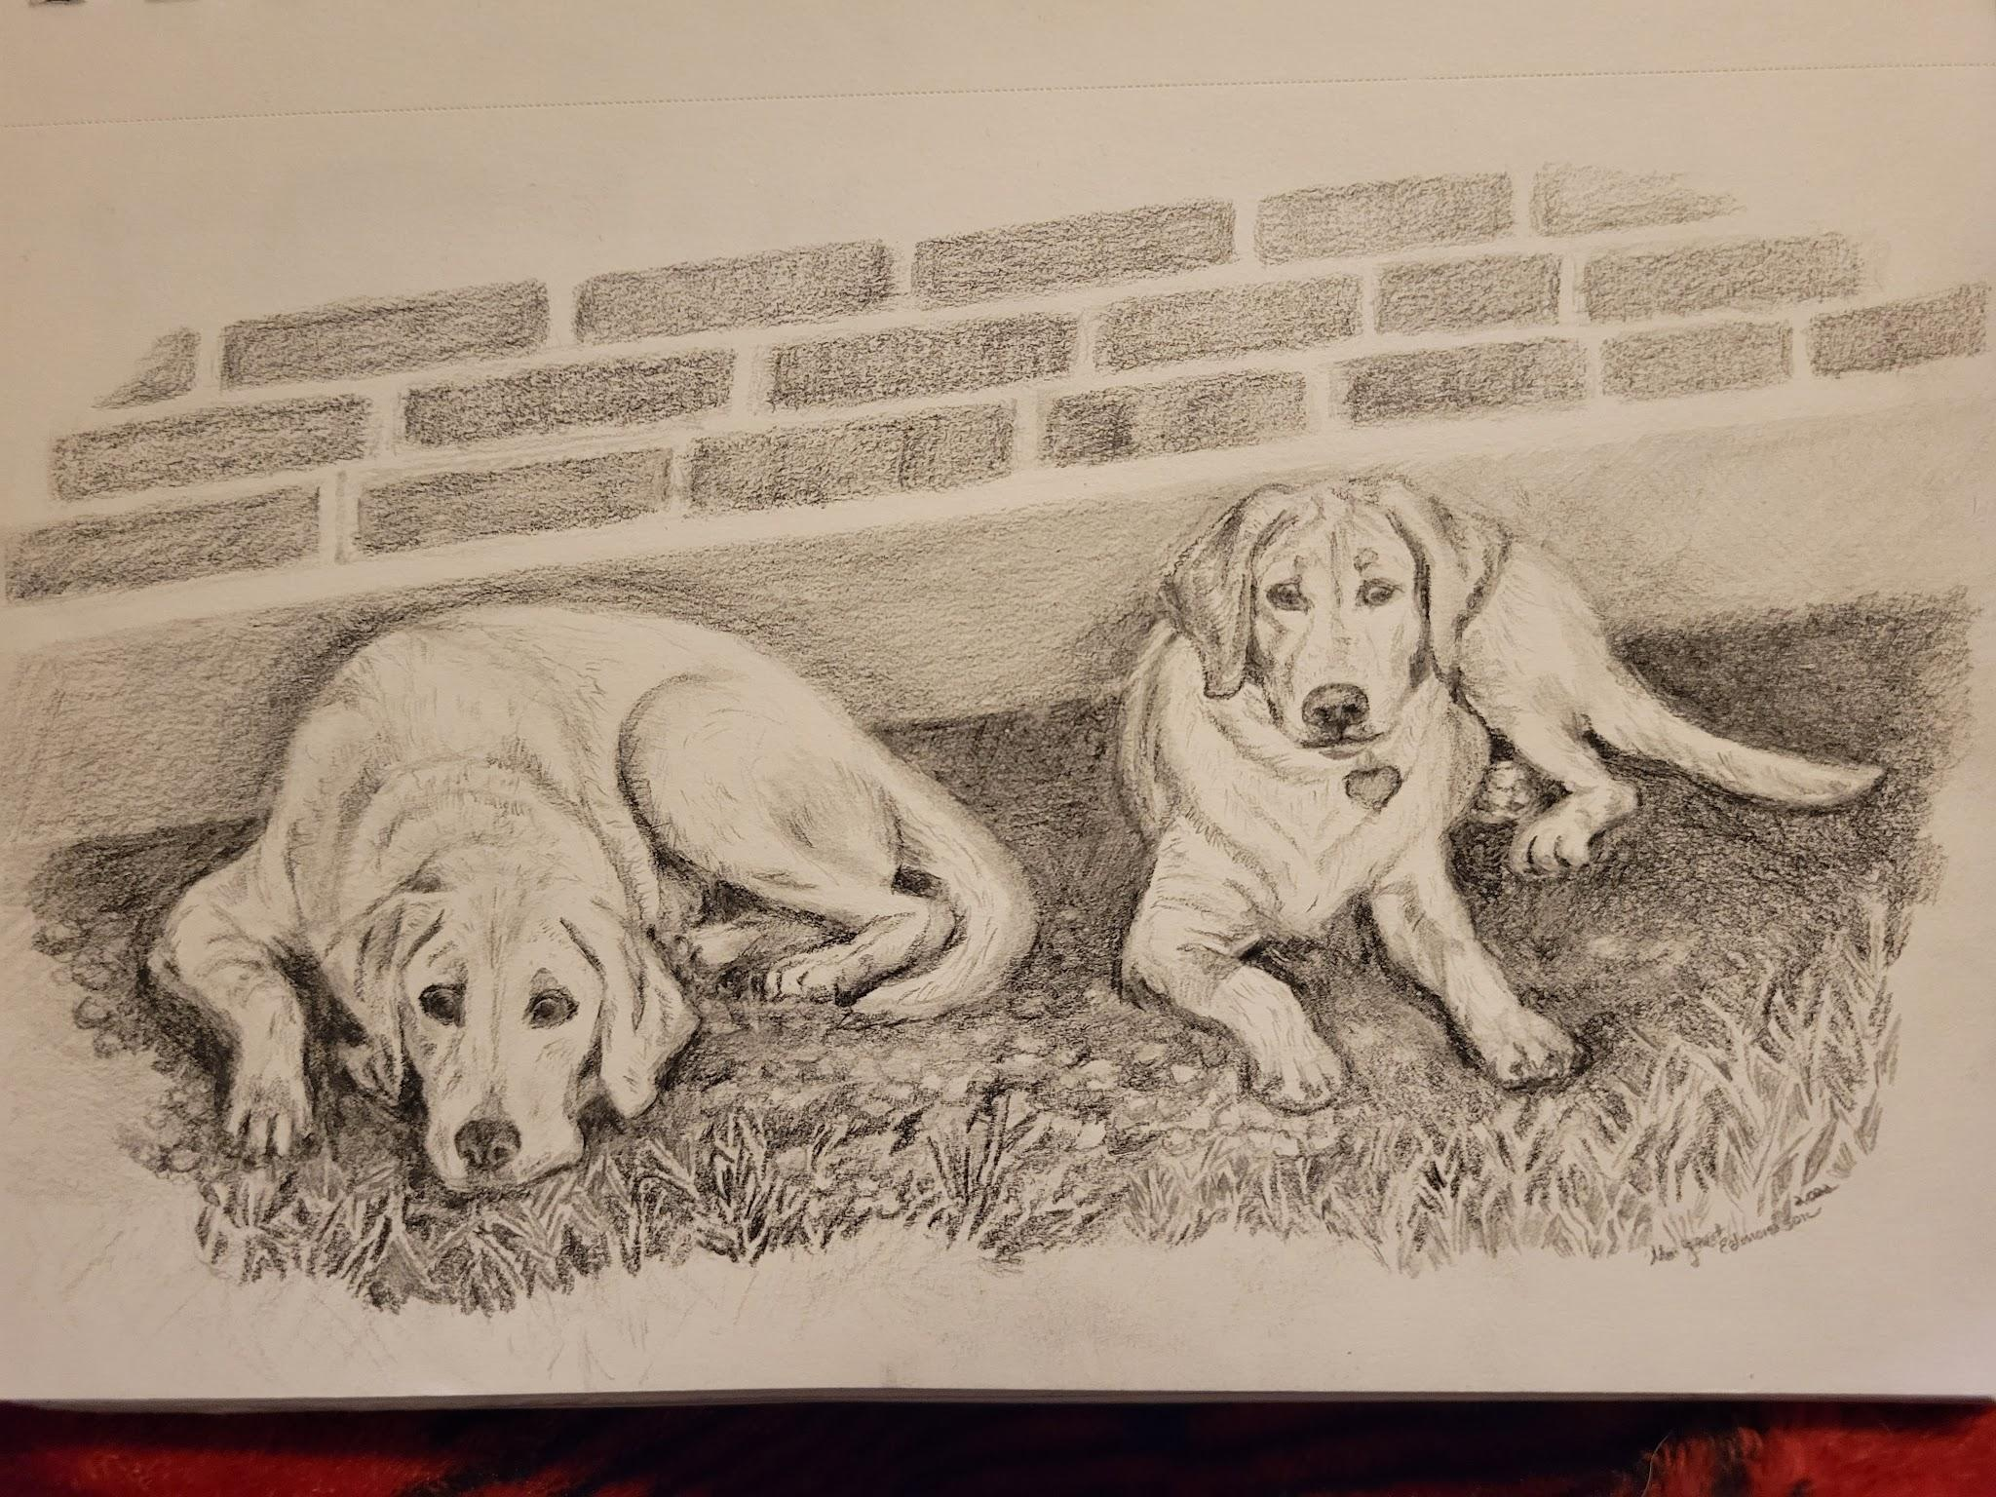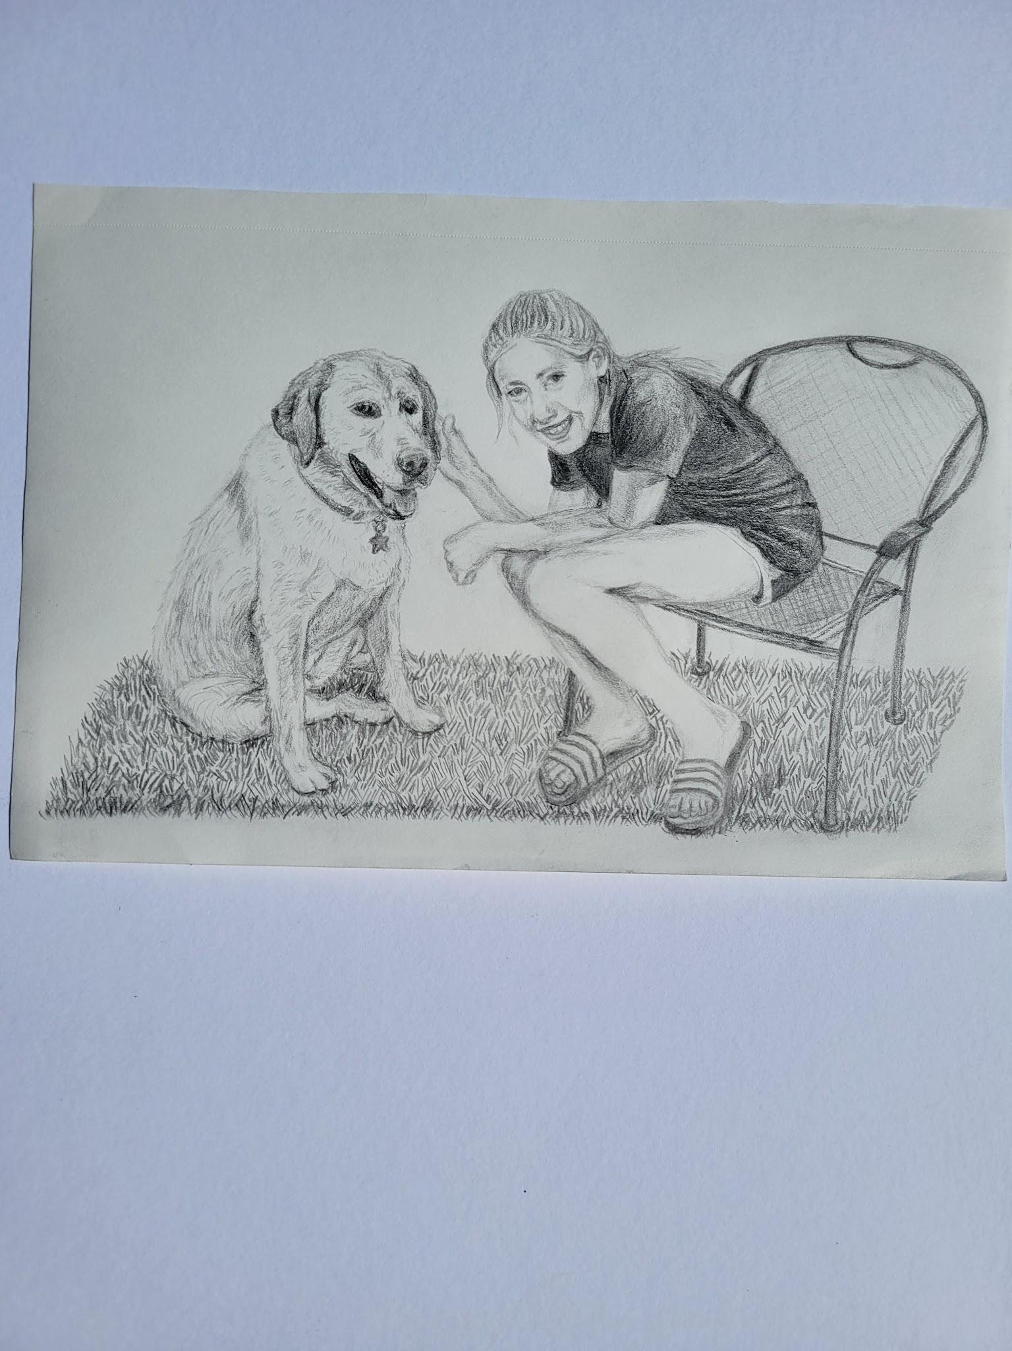
Drawings are of my dogs and my daughter. Painting below is an example of exaggerating color for a fun stylized look. Could easily delete this one from reference. I don’t really paint this way anymore so may should, but technically still can.
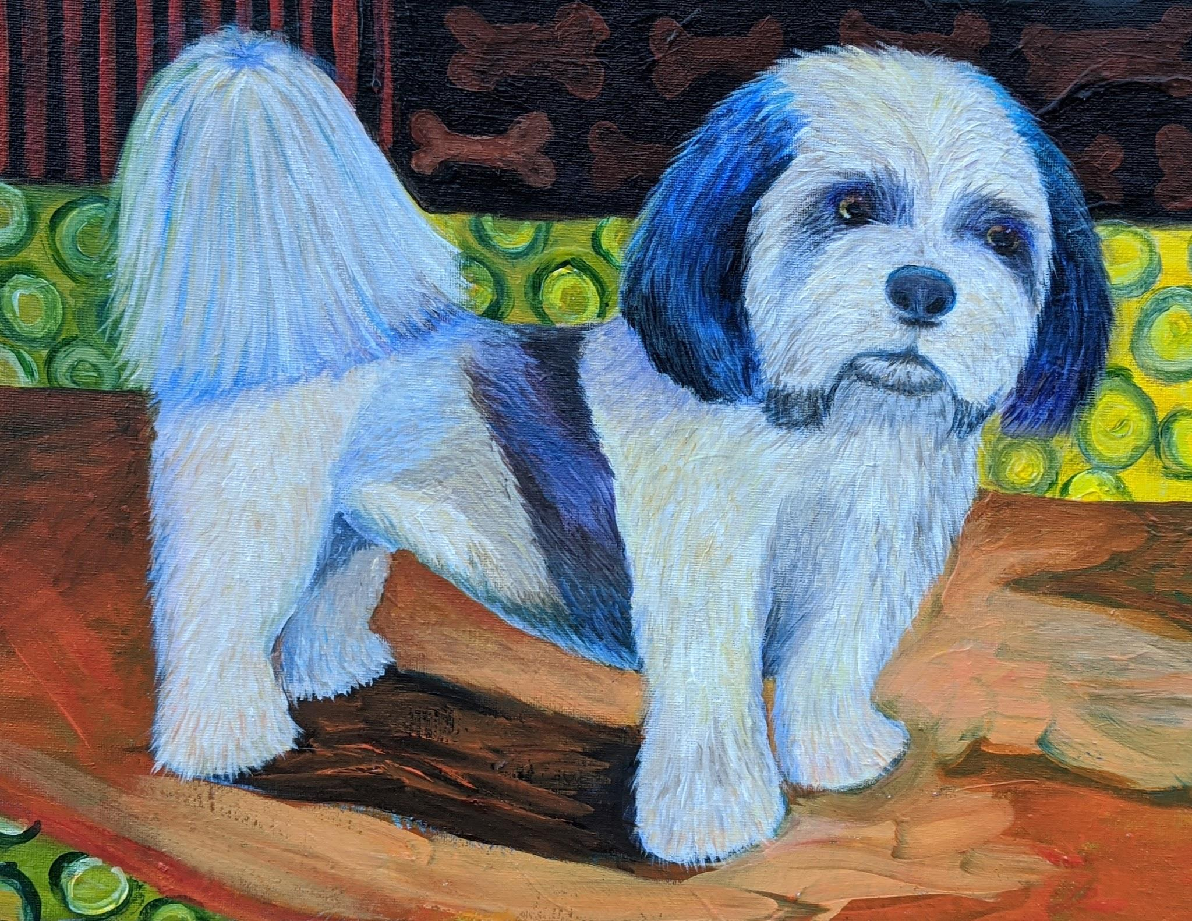

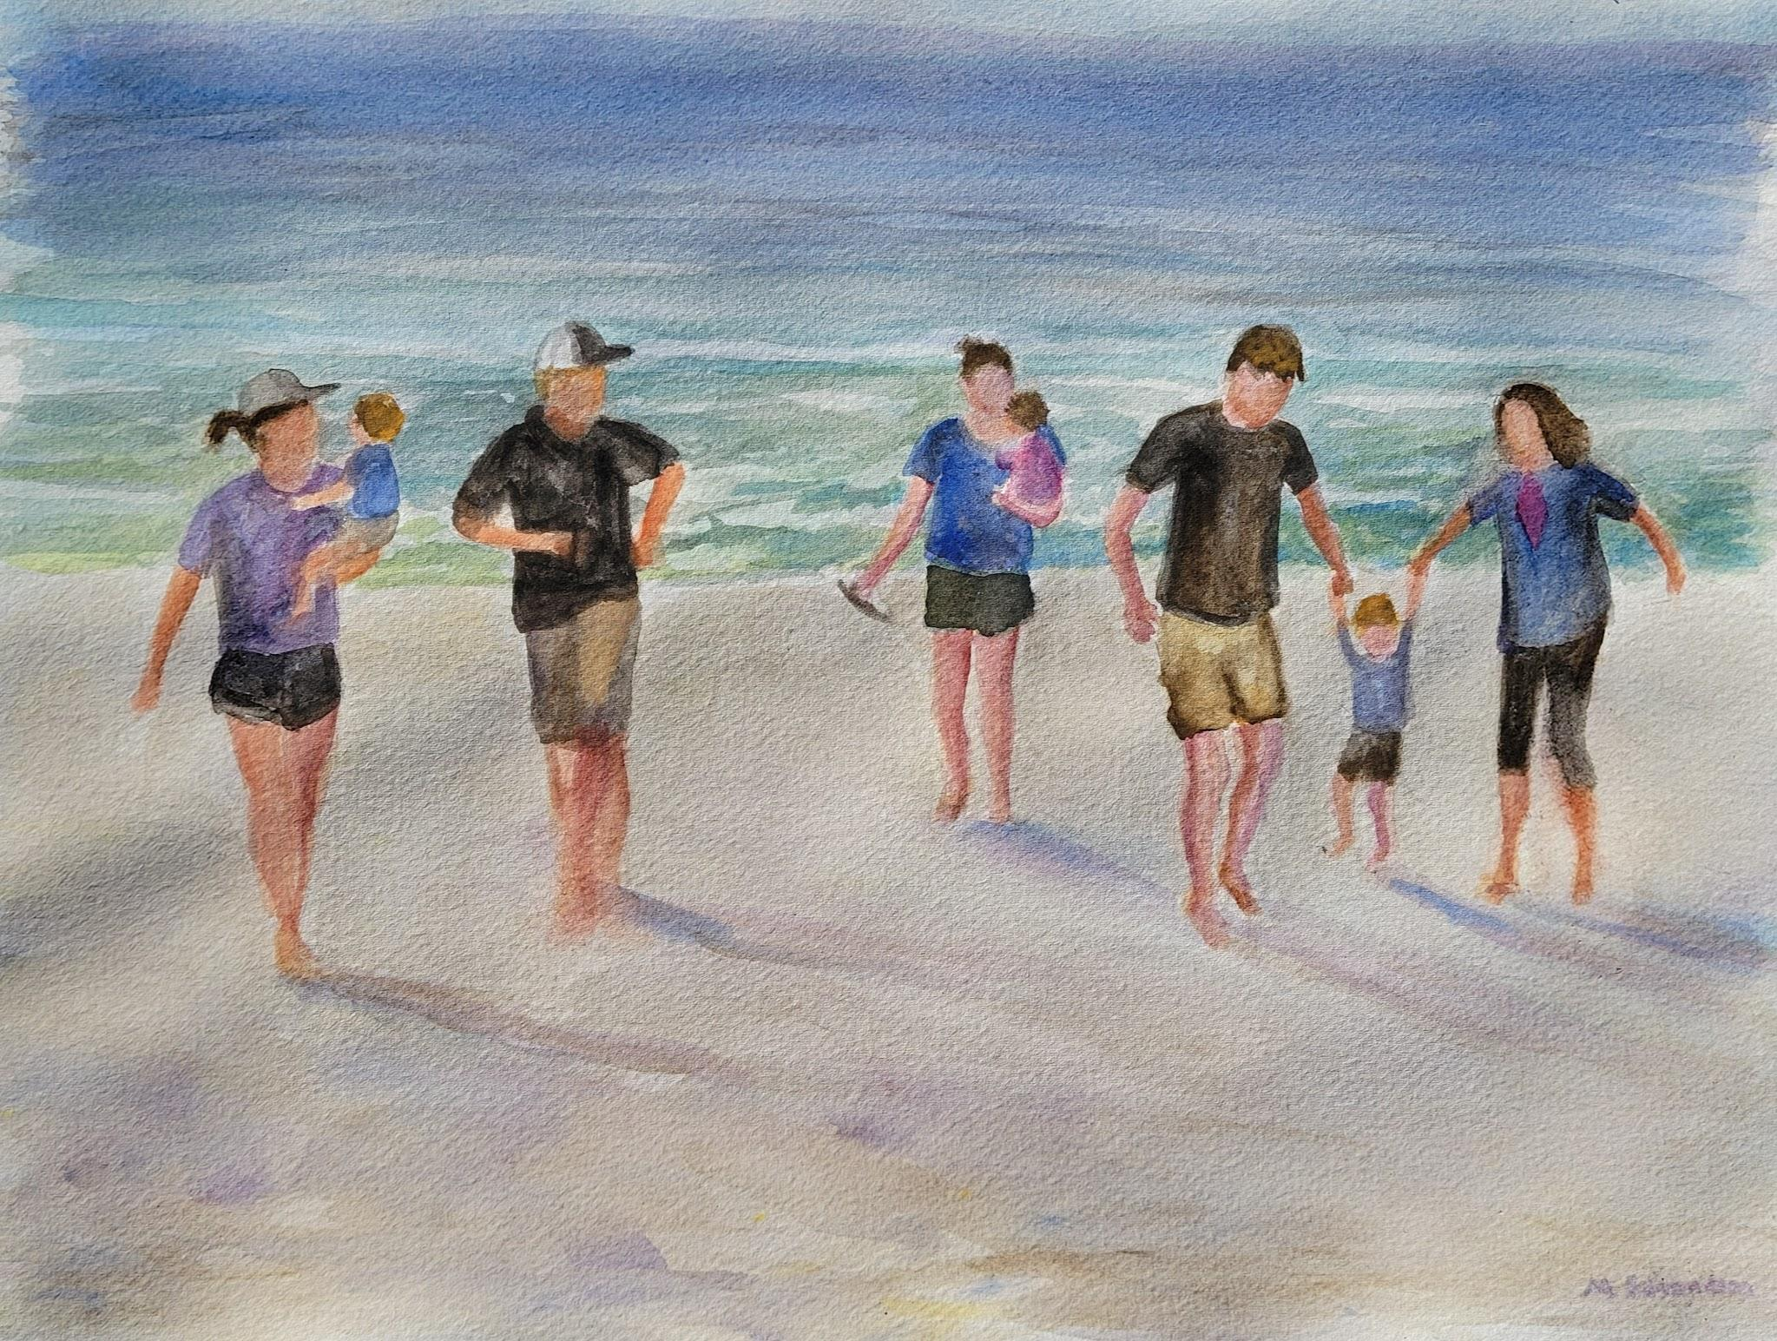
A painting that I did as a gift to a family member this year. I put together multiple photographs that I took and added a baby that had been born after I took these pictures. It is overall a simple painting with nondescript faces, but family time with a grandma, her two children and daughter in law and son in law with their children.
(Again, not sure that we want to say any of this, just giving you context. )

